Lung Cancer Detection Using 3D Convolutional Neural Network

Md. Jewel Rana
Department of Computer Science and Engineering
Brac University.
Dhaka,Bangladesh.
Anik Zaman, Tanzim Islam
Department of Computer Science and Engineering
Brac University.
Dhaka,Bangladesh.

Abstract—At present, the number of Lung cancer patients increasing day by day in the world. With the help of Machine Learning,3D Convolutional Neural Network and CT image from city scan data we can give predictions to the patients if they have lung cancer or not. In this paper, we proposed a model to detect lung malignancy cell using 3D Convolutional Neural Network and Machine Learning. Combined with the traditional morphological preprocessing methods,3Dconvolutional neural networks are applied to lung CT images. The experimental accuracy indicates that this method is suitable for the problem of lung malignancy cell detection and has great room to improve. The experimental results also demonstrate that the application of deep learning in the medical field will bring great progress for medical development.
Keywords— 3D Convolutional Neural Network, CT lung images, malignancy cell detection,deep learning.

Introduction
Statistics shows that, many Chinese people are diagnosed with lung cancer. According to National Cancer Center Data, there are 1.2 million people diagnosed with cancer and 7700 people died of cancer on average in 2015. And it is estimated that 1.8 million lung cancer cases were diagnosed each year globally. The number of lung cancer deaths among women surpasses those from breast cancer [1]. Since Computed Tomography (CT) is an important means of lung cancer detection, and in view of the complexity of the pulmonary nodule, the large number of CT images scanned by the lungs, especially the high-resolution scanned images make the number of images of a patient is more than 300 slices, and some of the lesion features are not obvious, which leads to the heavy work for doctors. So that, Artificial Intelligence used in the area of medical sector is much needed.
In past years, image processing techniques are used widely in the medical areas, for improving earlier detection, in
which the factor of time is very important to discover the disease in the patients, especially in various cancer tumors, such as the lung cancer and breast cancer. In general, this system first segments the area of interest and then analyze these segments and detect the obtained cell for diagnosis the disease. The geometric characteristics of pneumonic knob can be seen as the round shape. In terms of gray-scale distribution, it has a Gaussian conveyance. While, since of the imaging environment and other lung tissue impedances, the exposed eye may be troublesome to isolated aspiratory knob from other organization, which is especially troublesome to extricate vascular adhesions aspiratory knob. The think about of pneumonic cell detection calculation has continuously been a troublesome and hot spot in the field of computer-aided conclusion of CT images. And the conventional machine learning calculations are connected to most of the unusual location of lungs. The conventional strategies are strongly depended on the division and preprocessing of CT pictures. The last forecast and classification results strongly depend on the division comes about. Numerous strategies have been proposed over the final decades, such as morphological strategy of sectioning the pulmonary nodule [2]. As erosion and extension parameters are not easy to control, coming about in under-segmentation or over segmentation, nodule edge burr may too be disposed of. 2- dimensional pictures are prepared with the threshold segmentation, modeling, knob division, and so on [3]. However, as the demonstrate is less focused on, the impact of pulmonary nodule division of vascular attachments is destitute. When using the angle heading to decide the contrast between blood vessels and knob, knob can be extricated with EM and Means-Shift strategy [3]. It is not appropriate for vascular adhesion when its region more noteworthy than nodular. The dimensional reconstruction of 2-dimensional arrangement picture can diminish the nodular space characteristics but requires high-definition images [4]. Five stages included in the proposed CAD system are extraction of lung locale from chest computer tomography images, ivision of lung locale, include extraction from the fragmented locale, arrangement of conclusion rules frame the extracted highlights and classification of event and nonoccurrence of cancer in lungs [9].
A novel template-matching technique based on a hereditary calculation (GA) template matching (GATM) for identifying knob existing inside the lung range. The GA strategy was utilized to decide the target position in the watched picture productively and select an adequate layout picture from a few reference designs for quick layout coordinating [10]. Indeed, in spite of the fact that bounty of methods was proposed, it moreover has challenges in picture segmentation when utilizing conventional strategies. Profound learning has great advantages on enormous information preparing, and it gives a wealthy set of modeling dialects.
As of late, convolutional neural systems (CNNs) leveraging the learned high-level highlights have revolutionized natural picture handling [7]. Among these CNN architectures, 2D CNNs does not take the relationship between adjacent consecutive outlines in 3-dimensional space into account.

Therefore, in this paper, we will utilize 3D convolutional neural networks to the programmed location of pneumonic knob. Due to the characteristic of the "black box" of CNNs, it can learn features that the conventional machine learning strategies cannot learn, hence bring way better location result.

proposed methods

Image Segmentation
To begin with, the image is transfered from grayscale to RGB. At that point a series of operations such as edge division, corrosion, expansion are performed. At last, the associated region is used to get the cover of the CT image.
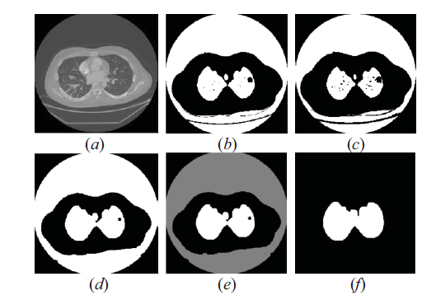
Fig 1. (a) original image (b) threshold segmentation result (c)
the eroded image (d) the dilated image (e) marked the
connected area (f) ROI area.

3D CNN Architecture
Based on the 3D convolution portrayed over, the corresponding CNN engineering can be planned. The 3DCNN is built upon 3D convolutional autoencoder [8]. The 3D CNN design for lung anomaly detection on at CT pictures is shown in Fig 2. As appeared in Fig. 2, we consider 20 cuts with measure of 50 × 50 as input to the 3D CNN demonstrate. Firstly, a set of hardwired kernels are utilized to create different channels from the input slice, which get 1×20 highlight maps in the moment layer. Secondly, 3D convolution with the part estimate of 3×3×3 is applied on each channel.
In arrange to increment the number of feature maps, two different convolutions is applied at each location, resulting in two sets of feature maps in the C2 layer. 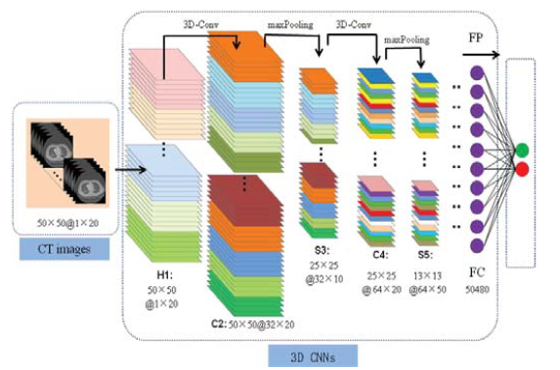

Fig 2. 3D CNN architecture for lung anomaly detection
based on CT images.

Each gather comprises of 32×20 feature maps. Thirdly, 3d max-pooling layer with the bit estimate of 2 × 2 × 2 connected on each of the highlight maps in the C2 layer, which leads to the same number of highlight maps of C2. The estimate of each cut is 25×25. Fourthly, 3D convolution with the part estimate of 3×3×3 is connected on S3, which can get 64×10 highlight maps with the measure of 25×25. Fifthly, 3d max-pooling layer with the kernel measure of 2×2×2 connected on each include maps in the C4 layer. We can get the same number of include maps with C4 layer with the measure of 13×13. At long last, the completely connected layer alter the estimate of 13×13×5×64 which is break even with to 54080 in 1024. And a dropout layer with the rate of 0.8 is utilized after reshape the shape of S5 in 28×28.Among the 3D-CNN structure, we include a ReLU activation work at each inner layer. After the neural network traning is completed, it is finalized by a fully-connected layer and a softmax layer with learning rate of 0.001.

3D Convolution and Pooling
In 2D CNNs, convolutions are connected on the 2D feature maps to compute highlights from the spatial measurements [5]. 3D convolution is a 3D shape by stacking different progressive frames, the 3D convolution part is utilized in the 3D shape. In this structure, each highlight outline in the convolution layer is associated to a number of adjoining continuous outlines in the upper layer. Lung CT picture is the body of the lung organized into a number of 3D shapes agreeing to a certain thickness level, which means the essential unit is voxel. When the convolution of the network used in the recognizable proof of CT picture, in arrange to capture multiple successive outlines, we propose a 3D convolution in the CNN convolution organize to compute the 3D space features. The 3D bit is convoluted with a 3D shape shaped by superimposing a majority of adjoining outlines. This structure allows the highlight outline in the convolution layer to be connected to different progressive outlines.

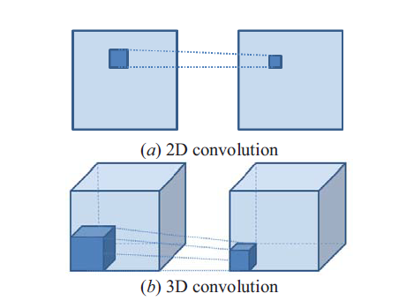

Fig 3. Comparison of (a) 2D convolution and (b) 3D
convolution.

Thinks about appear that 3D ConvNet is well-suited for spatiotemporal feature learning. Compared to 2D ConvNet, 3D ConvNet has the capacity to show worldly data better owing to 3D convolution and 3D pooling operations. In 3D ConvNets, convolution and pooling operations are performed spatio-temporally while 2D ConvNets are as it were in spatial [6].

experiments
We have gotten CT filters of almost 1595 patients. At that point we build another record that contains the names of this information. Finally, the 3D convolutional neural systems is utilized to lung cancer recognition on this dataset.

CT Lung Image Data Set

CT Images
Computer tomography (CT) utilize x-ray to the human body with a certain level of checking. The remade picture is obtained after preparing by computer. CT pictures are really anatomical layers, the pictures are white on the skeleton, and the liver of the brain is dark. Concurring to the contrasts of the thickness among the tissues, it is appeared in diverse degrees of gray.
The lung CT pictures have low noise when compared to scan pictures and MRI pictures. Hence, we can take the CT images for recognizing the lungs. The fundamental advantage of the computer tomography picture are way better clarity, low noise and distortion. The cruel and Change can be effectively calculated. The calculated esteem is exceptionally closer to the unique esteem [12].

Digital imaging And Communicatons In medicine
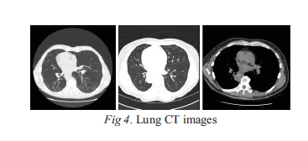
Digital Imaging and Communications in Medicine (DICOM),
an international standard for medical imaging and communication. It is a medical document that stored in DICOM standard format with a suffix of ‘.dcm’. It is usually
composed of DICOM files and an image data set.

Prepocessing Steps

Handling Data:
At this point, we have obtained the list of patients by their Ids. And their associated labels is stored in a dataframe. Now, we begin to iterate through the patients and gather their respective data.

Prepocessed data showing

Resizing the image from 512x512 to 50x50 Which is shown in figure 5.
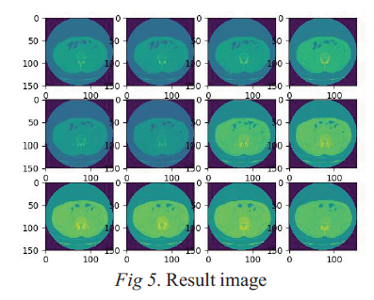

In the dataset, the number of cuts contained in patients' CT pictures is not uniform. We bound together the number of slices into 20. The gray scale colormap appeared in Fig 6 indicate that a few checks are fair darker than others generally.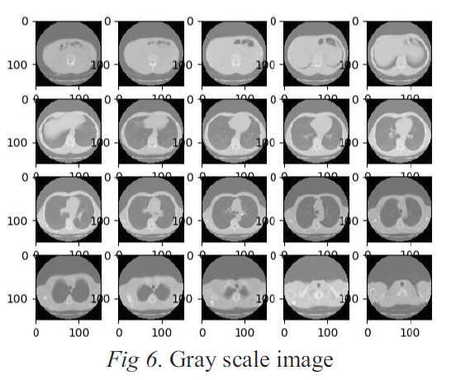

Preprocessing all of the data into one file which makes the training likely be faster

3D Convolutional Neural Network
We define the weights and biases of the convolutional
neural network. The weight of conv1 is 3×3×3 patches, the
input size of 1, the output size of 32. The weight of conv2 is of
size 3×3×3 with the input size of 32 and the output size of 64.
The size of fully-connected layer is 1024. The biases of conv1
is 32, which corresponding to 32 feature maps. And the biases
of conv2 is 64, the biases of fully-connected layer is 1024, the
classes of output layer is 2. Then the formula of fitting,
activate function, and dropout are defined with 80%. Finally,
the results are given.

Results
As for the distinguishing proof of pneumonic knob, the feature extraction combined with LS-SVM has been connected to it. And the result of our experiment after 10 epochs, the exactness rate can reach over 65.6%.
By analyzing the comes about, we can conclude that SVM has lower classification exactness than 3D convolutional neural networks in the same number of tests. With the increasing number of tests, its preparing speed and execution are worse than 3D convolutional neural systems. And 3D convolutional neural systems utilized in CT pneumonic nodule detection is as it were in the introductory arrange, which has more noteworthy room to improve.

conclusion
Since deep learning applied to medical pictures is still at embryonic arrange, 3D convolutional neural systems has some achievements in the location of lung CT variations from the norm as shown in this paper. The comes about appear that the 3D convolutional neural systems are compelling in the discovery of lung cancer. And the reason why the result is not truly ideal greatly is that the database is not expansive sufficient, the image preprocessing is not exceptionally appropriate for the systems. Afterward, we will make a few changes in these parts.

refferences
[1] Kostis W J, Reeves A P, Yankelewitz D F, et al.Three-dimensional segmentation and growth-rate estimation of small pulmonary nodule in helical CT images[J].IEEE Transactions on Medical Imaging, 2003,22(10):1259-1274.
[2] Farag A A, Graham J, Elshazly S, et al. Data-driven lung nodule models for robust nodule detection in chest CT [C]. Processing of International Conference in Pattern Recognition. Los Alamitos: IEEE Computer Society Press,2010:2588-2591.
[3] Sun Shenshen, Li Hong, Hou Xinran, et al. Pulmonary nodule segmentation based on EM and Mean-shift [J]. Journal of Image and Graphics, 2009, 14(10):2016-2022.
[4] Takemura S,Han Xianhua,Chen Yenwei, et al.Enhancement and detection of lung nodule with multiscale filters in CT images[C].Processings of International Conference on Intelligent Information Hiding and Multimedia Signal Processing. Los Alamitors:IEEE Computer SocityPress, 2008:717-720.
[5] Shuiwang Ji,Wei Xu,Ming Yang,Kai Yu. 3D Convolutional Neural Networks for Human Action Recognition [J]. IEEE Transactions on Pattern Analysis & Machine Intelligence, 2013 , 35 (1) :221.
[6] Du Tran, Lubomir Bourdev, Rob Fergus , Lorenzo Torresani, Manohar Paluri, et al. Learning Spatiotemporal Features with 3D Convolutional Networks[J]. IEEE International Conference on Computer Vision, 2016 :4489-4497.
[7] Qi Dou, Hao Chen, Yueming Jin, Lequan Yu, et al. 3D Deeply Supervised Network for Automatic Liver Segmentation from CT Volumes. International Conference on Medical Image Computing & Computer-assisted Intervention, 2016 :149-157.
[8] E Hosseiniasl, R Keynton, A Elbaz. Alzheimer's Disease Diagnostics by a Deeply Supervised Adaptable 3D Convolutional Network. IEEE International Conference on Image Processing, 2016.
[9] Arman Adel Abdullah, Emy Haryatmi, A computer aided diagnosis system for lung cancer detection using machine learning technique,􅱓European Journal of Scientific Research􀇊, 2011 , 7 (2).
[10] Lee Y, Hara T, Fujita H, !toh S, Ishigaki T, 2001 Automated detection of pulmonary nodule in helical CT images based on an improved template-matching technique, IEEE Trans. Med. Imaging, Vol. 20,pp.595-604.
[11] Bezdek, James C. (1981). Pattern Recognition with Fuzzy Objective Function Algorithms. ISBN 0-306-40671-3.
[12] Disha Sharma, Gagandeep Jindal. Identifying Lung Cancer Using Image Processing Techniques. International Conference on Computational Techniques and Artificial Intelligence.2011.

